NAME S Surender

REG NO:1924260070

Set 15: Product Sales Analysis (Unit IV)

Question 1: Bar Chart

Aim
To create a grouped bar chart comparing the monthly sales of each product.

Procedure
- Load ggplot2 and create the sales data frame.
- Convert it to long format (Product, Month, Sales).
- Draw a grouped bar chart with title and axis labels.

Code
library(ggplot2); library(gridExtra)
p <- data.frame(ID=1:3, Product=c("Product A","Product B","Product C"), Jan=c(2000,1500,1200), Feb=c(2200,1800,1400), Mar=c(2400,1600,1100))
l <- data.frame(Product=rep(p$Product,3), Month=factor(rep(c("Jan","Feb","Mar"), each=3),
levels=c("Jan","Feb","Mar")), Sales=c(p$Jan, p$Feb, p$Mar))
b <- ggplot(l, aes(Month, Sales, fill=Product)) + geom_col(position="dodge") +
labs(title="Monthly Sales by Product", x="Month", y="Sales") print(b)

Output
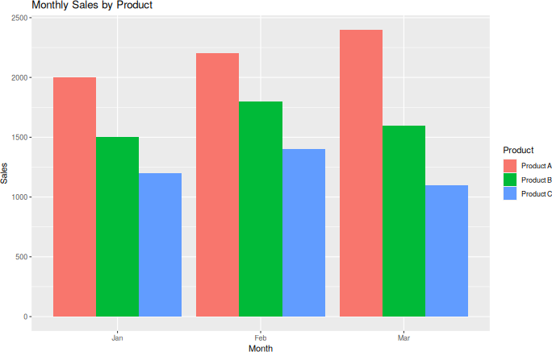
Fig 1: Bar chart – Monthly sales by product

Result
The bar chart was created. Product A has the highest sales in every month.

Question 2: Line Chart

Aim
To show the sales trend of each product from January to March using a line chart.

Procedure
- Use the long-format data (l).
- Draw one line per product with points, title and axis labels.

Code
n <- ggplot(l, aes(Month, Sales, group=Product, color=Product)) + geom_line() + geom_point() + labs(title="Sales Trend (Jan-Mar)",
x="Month", y="Sales") print(n)

Output
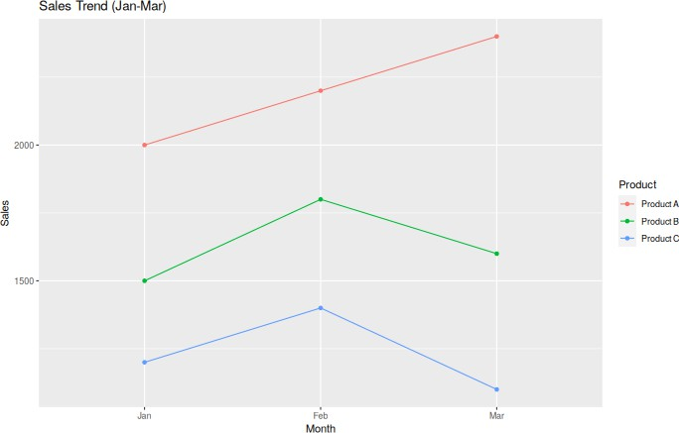
Fig 2: Line chart – Sales trend

Result
The line chart was created. Product A rises every month, while Products B and C fall in March.

Question 3: Table and Dashboard

Aim
To build a sales table with totals and combine it with the charts into one dashboard.

Procedure
- Add a Total column to the sales data.
- Print the table and draw it using tableGrob().
- Combine the bar chart, line chart and table using grid.arrange().

Code
p$Total <- p$Jan + p$Feb + p$Mar print(p)
t <- tableGrob(p, rows=NULL) grid.arrange(b, n, t, ncol=2)

Output

Console output:
ID Product Jan Feb Mar Total
1 1 Product A 2000 2200 2400 6600
2 2 Product B 1500 1800 1600 4900
3 3 Product C 1200 1400 1100 3700
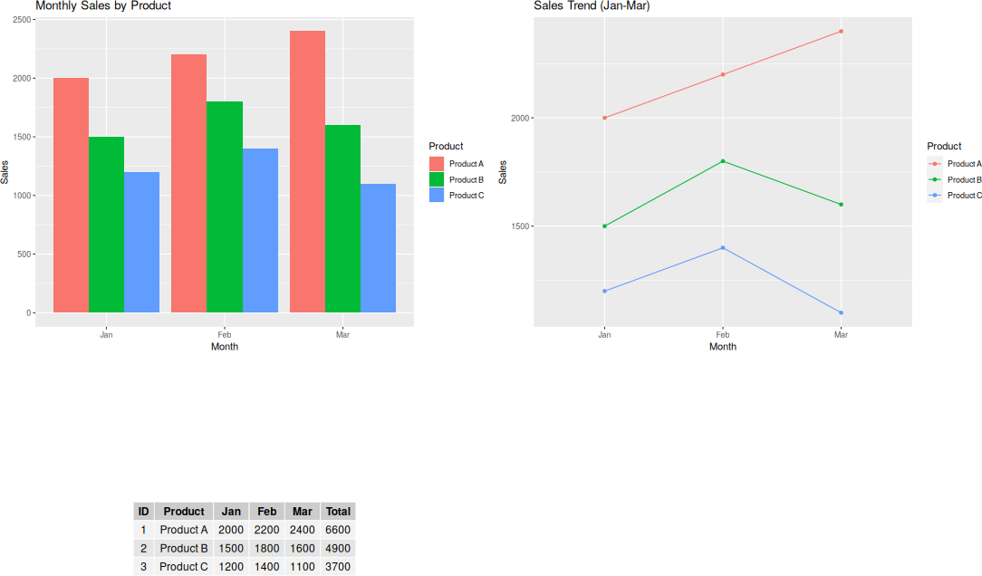

Fig 3: Dashboard (bar + line + table)

Result
The table and dashboard were created. Product A has the highest total sales (6600), then Product B (4900) and Product C (3700).

